Fashion Clickstream Funnel Analysis – Project Report

1. Executive Summary
This project analyzes user behavior across a fashion e-commerce platform using clickstream data. The dashboards provide a clear view of how users navigate through the shopping funnel, from initial sessions to final purchases. Overall traffic is strong, especially on mobile devices, but conversions remain lower compared to desktops. A noticeable drop-off is seen before checkout, and campaign performance varies in terms of acquisition cost. These insights help understand user engagement patterns and areas for funnel optimization.

2. Objective / Business Question
The purpose of this project is to understand:
- How users interact across devices, categories, and events?
- Where major drop-offs occur in the shopping funnel?
- What factors impact conversions, revenue, and cart abandonment?
- How campaign performance influences acquisition cost?
- How clickstream behavior can guide improvements in user experience?

3. Key Metrics / KPIs
The following KPIs were analyzed through the dashboard:
- Total Sessions
- Total Orders
- Conversion Rate
- Average Order Value (AOV)
- Total Revenue
- Cart Abandonment Rate
- Drop-off Users
- Cost Per Acquisition (CPA)
These KPIs help measure engagement, efficiency, and performance across the funnel.

4. Insights & Findings

Insight 1: Mobile contributes the highest number of sessions
Mobile traffic dominates overall sessions. However, mobile does not convert as strongly as desktop.
This suggests that while users browse on mobile, they may not feel comfortable purchasing.
Improving the mobile checkout flow may increase conversions.

Insight 2: Major drop-off occurs before the purchase stage
Funnel visualization shows strong movement from Home → Product View → Add to Cart, but noticeable drop-off before purchase.
This indicates friction in the later part of the journey.
Reducing steps, simplifying payment, or offering incentives can help reduce drop-offs.

Insight 3: Cart abandonment rate is high
Cart Abandonment Rate is one of the key issues highlighted in the dashboard.
Users add products to the cart but do not proceed to checkout.
Introducing features like reminders, limited-time offers, or easier checkout can support recovery.

Insight 4: CPA varies significantly across campaigns
Some campaigns deliver conversions efficiently, while others have a higher cost per acquisition.
This suggests uneven performance across campaigns.
Budget can be optimized by focusing on campaigns with better CPA trends.

Insight 5: Session activity peaks during specific hours
The event-hour line chart shows clear session spikes during evening hours.
This shows when users are most active.
Marketing and promotional activities can be scheduled during high-traffic periods.

5. Supporting Visuals in the Dashboard

Page 1 – User Engagement Overview

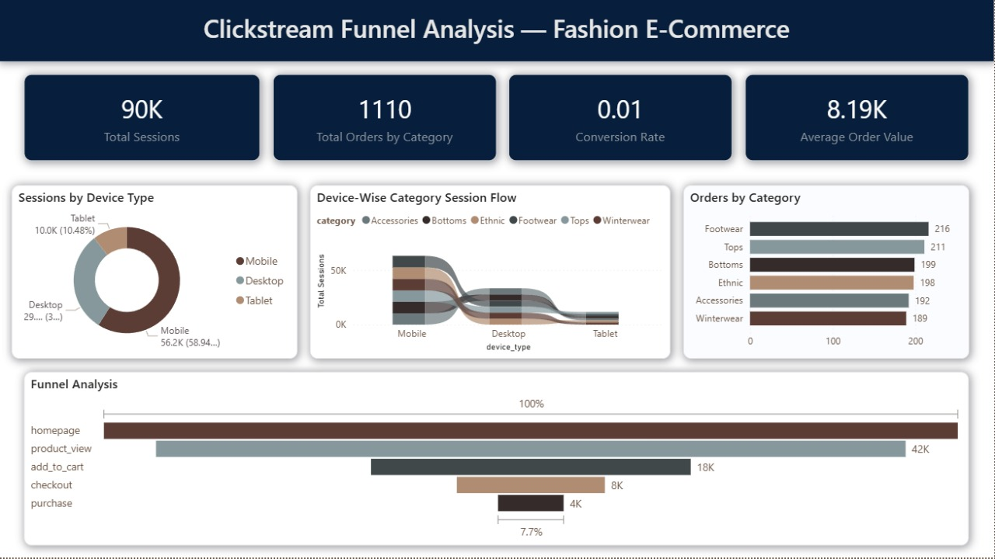

- Total Sessions, Total Orders, Conversion Rate, AOV
- Donut Chart: Sessions by Device Type
- Clustered Bar Chart: Orders by Category
- Funnel Chart: Homepage → Product View → Add to Cart → Purchase

Page 2 – Behavior and Interaction Analysis

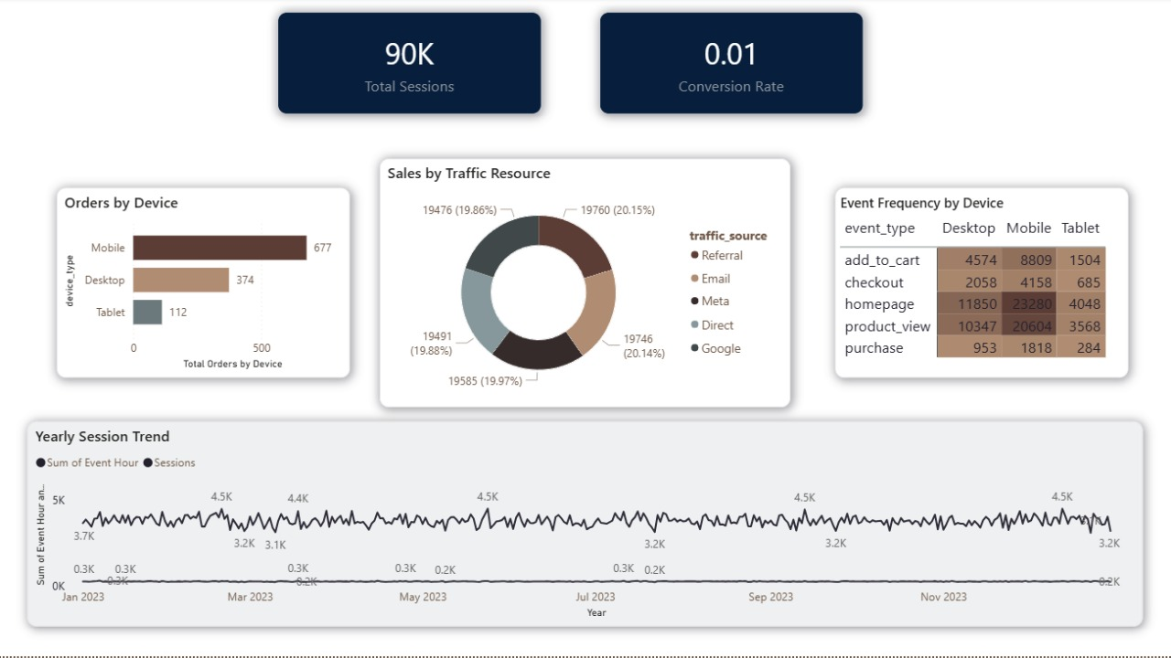

- Total Sessions, Conversion Rate
- Bar Chart: Orders by Device
- Donut Chart: Sessions by Traffic Source
- Matrix/Heatmap: Event Frequency by Device Type
- Line Chart: Event Hour vs Sessions

Page 3 – Funnel Efficiency and Campaign Analysis

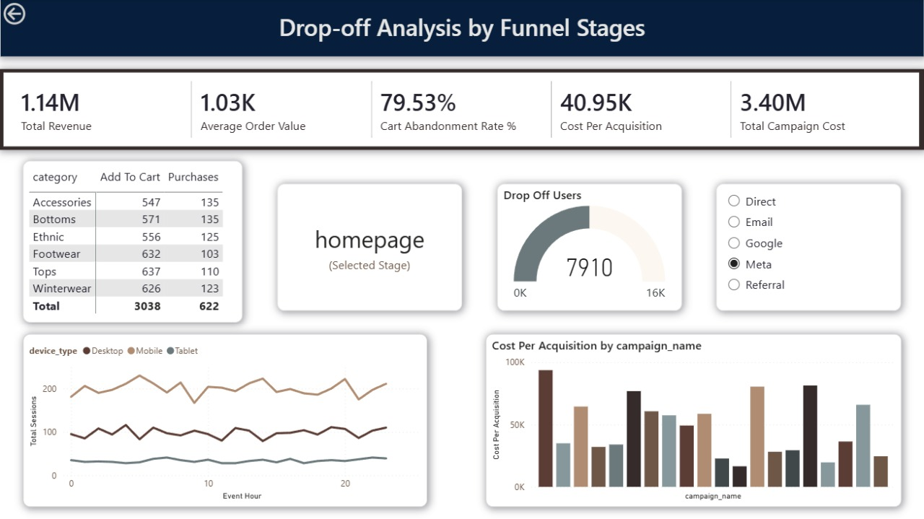

- Total Revenue, AOV, Cart Abandonment Rate, CPA
- Line Chart: Sessions by Event Hour
- Drop-off Users Gauge
- Bar Chart: CPA by Campaign Name

6. Limitations
- Dataset does not include demographic information for deeper analysis.
- Campaign dataset lacks details about impressions or clicks.
- Reasons behind drop-offs or abandoned carts are not directly available.
- The timeframe of the dataset may limit long-term trend detection.

7. Recommendations
- Improve mobile checkout experience to increase conversions.
- Address cart abandonment by implementing reminders, discount nudges, or faster checkout.
- Reallocate marketing budget toward lower-CPA campaigns.
- Analyze underperforming categories and optimize product presentation.
- Use peak-activity hours to schedule promotional pushes

